## horizontal line



**Virtual Wardrobe for Stitch-Fix**

Pooja Dharmadhikari

Anuja Suryawanshi

Sayali Bhagat

Final Project : INFO 7374 Digital Marketing Analysis

# Overview

Trying on clothes once you receive a fix box is one of the most time-consuming tasks. Usually long waiting periods have to be taken into account, for example trying out the cloths and returning back the ones not fitting or liked. Reducing this time and helping people to put on a large collection of garments in reduced time was a relevant motivation for this thesis. Using modern technology, the try-on experience can be drastically improved.

Even in web shops people are very sceptic buying clothes because a try-on of clothes is not possible. The techniques discussed in this paper can enhance the shopping experience. It even offers customers a more precise representation than 2D images of the cloth they are willing to buy and therefore this may also reduce the amount of goods the buyers return.

In this thesis we will introduce a Virtual Dressing Room, which offers a solution for the mentioned aspects. The module is based on a mirror, represented by a display that outputs the image of the camera. If a person is giving images of them, the person will be able to select desired clothes. The selected garment is then virtually superimposed with the image recorded by the camera. In general, this technique can be categorized under augmented reality (AR), where a real-time view of the reality is extended and furthermore overlaid with additional information. This paper mainly focuses on the applications in cloth stores

# Goals

The aim of the thesis is to create a Virtual Dressing Room that realistically reflects the appearance and the behavior of garment. It should further adapt to specific bodies of different persons depending on their body measurements. This will be one of the main challenges since the pieces of cloth should correctly fit to as many persons as possible independent of their individual dimensions

# Use Cases

**Time-consumption-** Decreasing the fit time for customer, reduction in delivery revenue and inventory management

**Clothing fit and size-** Recommendation for the customer as per the shape and size

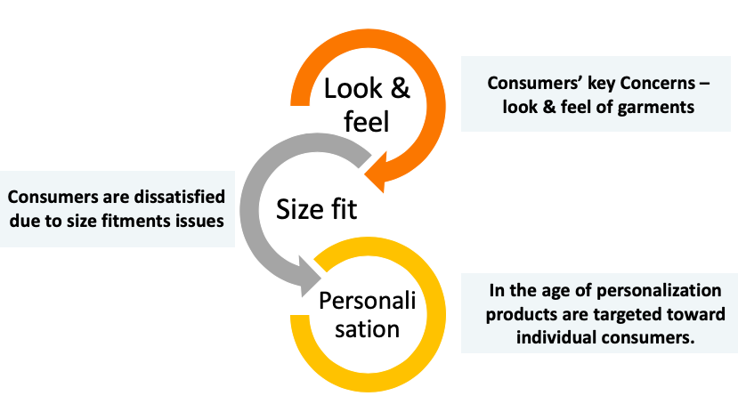

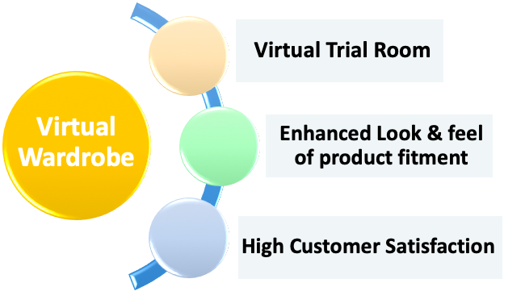

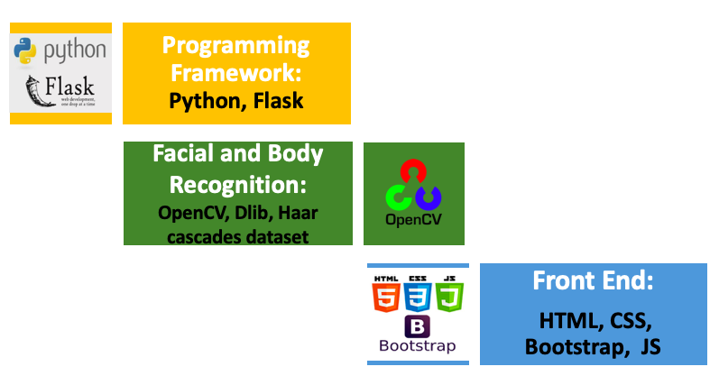

# Process Outline

1. Data Preprocessing

* Data Cleaning, handling missing values

2. Exploratory Data Analysis

3. Study of Supervised approaches and select the best model for prediction

4. Study of Unsupervised approaches (Clustering and Associative rule mining) for recommendation

5. Design of a pipeline and system to implement this approach and discussion on the system’s capabilities

6. Deploy the Model on Azure/AWS or Google Cloud Computing Platform

7. Build a web application to demonstrate the prediction and recommendation results.

# Milestones

|  |  |
| --- | --- |
| **Timeframe** | **Delivery** |
| Day 1-2 | Data Preprocessing and Exploratory Data Analysis |
| Day 3-6 | Model Building, Training, Selection |
| Day 7-8 | Deployment of models on cloud and build web application |
| Day 9-10 | System integration and documentation |

## **Deployment Details:**

1. Language: Python
2. Pipeline: Luigi
3. Container: Docker
4. Cloud Tools/Platforms: Microsoft Azure Machine Learning Studio,AWS (Amazon WEb Services) EC2
5. Tools for Analysis: Microsoft Azure Visual Studio, ArchGIS
6. Other Considerations: Google Cloud Platform

## **Reference and Sources:**

This project builds from the work listed below:

* Human parsing
  + LIP_JPPNet ([repo](https://github.com/Engineering-Course/LIP_JPPNet), [paper](https://arxiv.org/abs/1804.01984))
* Pose estimation
  + Realtime Multi-Person Pose Estimation ([repo](https://github.com/ZheC/Realtime_Multi-Person_Pose_Estimation), [paper](https://arxiv.org/abs/1611.08050))
    - [Keras implementation](https://github.com/michalfaber/keras_Realtime_Multi-Person_Pose_Estimation)
* Virtual try-on
  + VITON ([repo](https://github.com/xthan/VITON), [paper](https://arxiv.org/abs/1711.08447))